**Jenkins Master** - **Slave concept**

**Pre-requisites:**

* Jenkins Master Instance
* Jenkins Slave Instance

**Jenkins Slave Instance:**

Install Docker:

yum install -y docker

service docker start

usermod -a -G docker ec2-user

Install Git:

yum install git

git clone <https://github.com/bibinwilson/jenkins-docker-slave.git>

Build Docker Image:

cd jenkins-docker-slave

docker build -t naresh240/jenkins-slave:latest .

docker login

docker push naresh240/jenkins-slave:latest

Jenkins Master Instance:

Install Java:

yum install java-1.8.0-openjdk –y

Install Jenkins:

sudo wget -O /etc/yum.repos.d/jenkins.repo http://pkg.jenkins-ci.org/redhat-stable/jenkins.repo

sudo rpm --import https://jenkins-ci.org/redhat/jenkins-ci.org.key

sudo yum install jenkins -y

sudo service jenkins start

Install Docker:

yum install -y docker

service docker start

usermod -a -G docker Jenkins

Restart Jenkins:

Sudo service jenkins restart

Open Jenkins in UI:

<ip-address>:8080

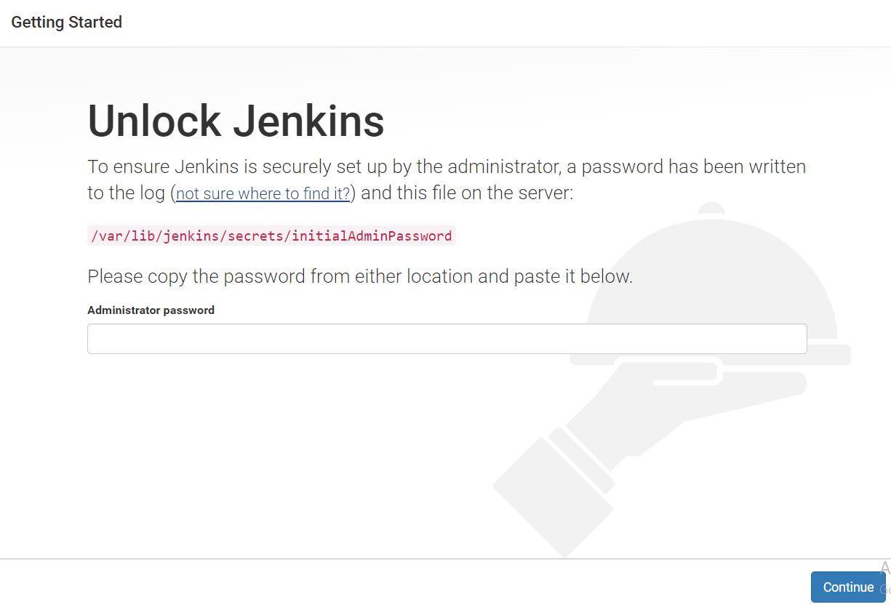

cat /var/lib/jenkins/secrets/initialAdminPassword



Copy password and paste in UI and then Click on **Continue**

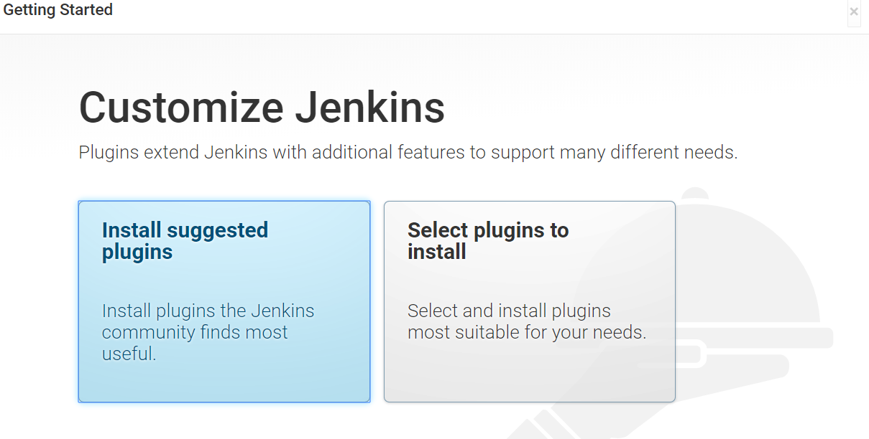

Click on **Install suggested plugins**

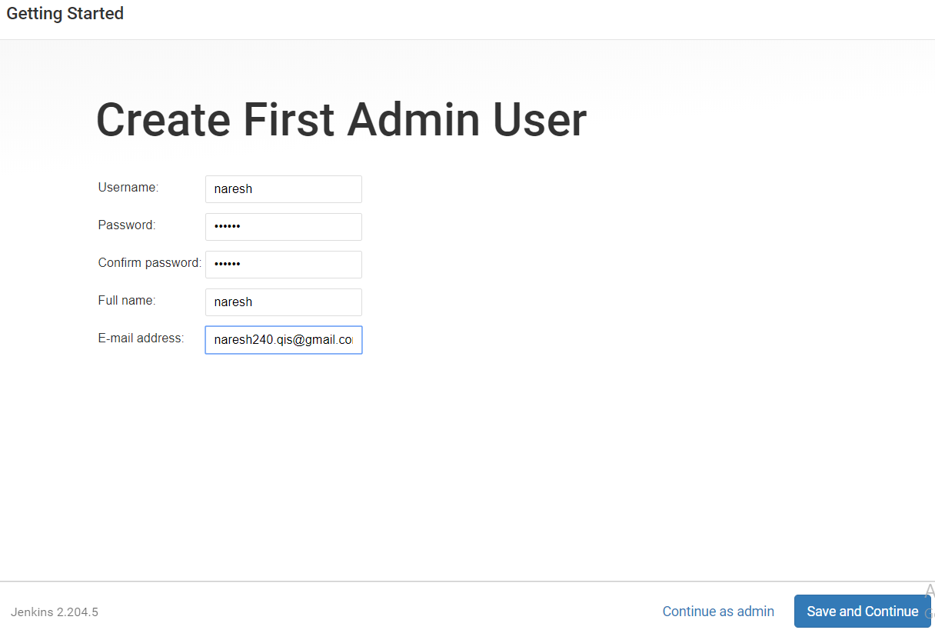

Provide details as above and click on **Save and Continue**

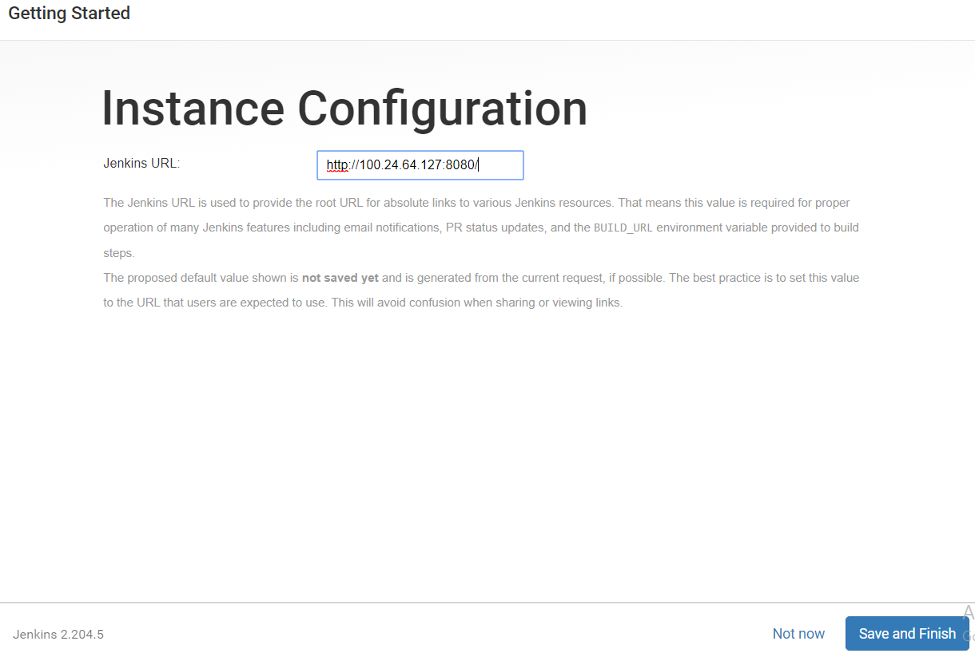

Click on **Save and Finish**

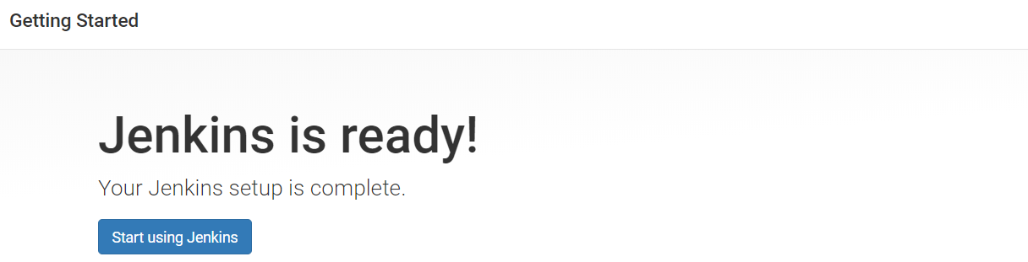

Click on **Start using Jenkins**

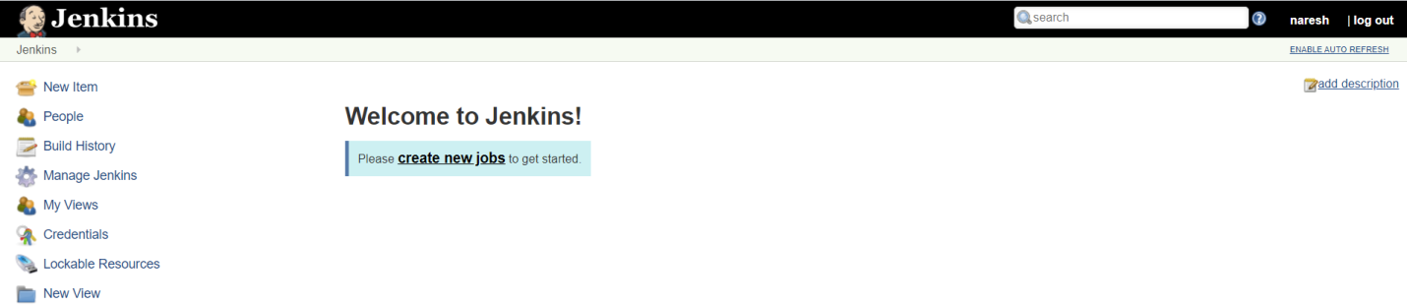

Install **docker plugins** to Jenkins:

Click on **Manage Jenkins**

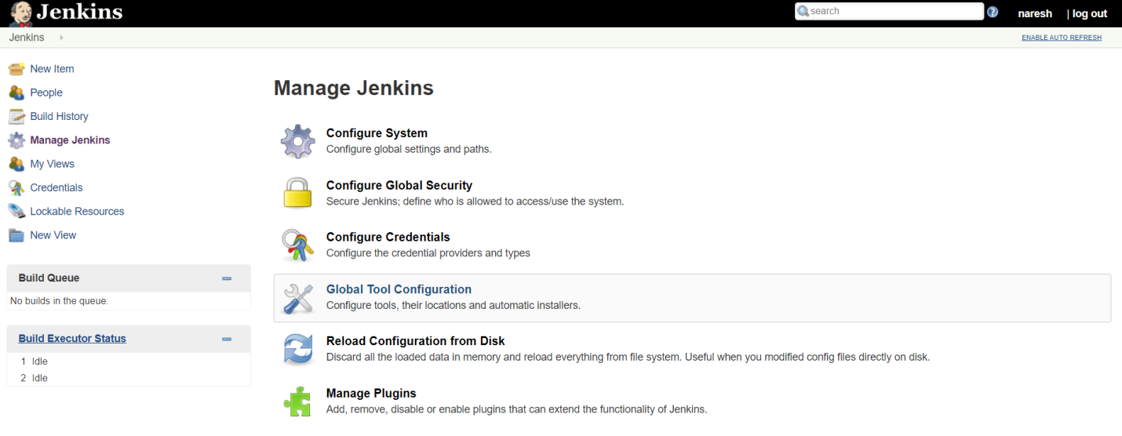

Click on **Manage plugins**

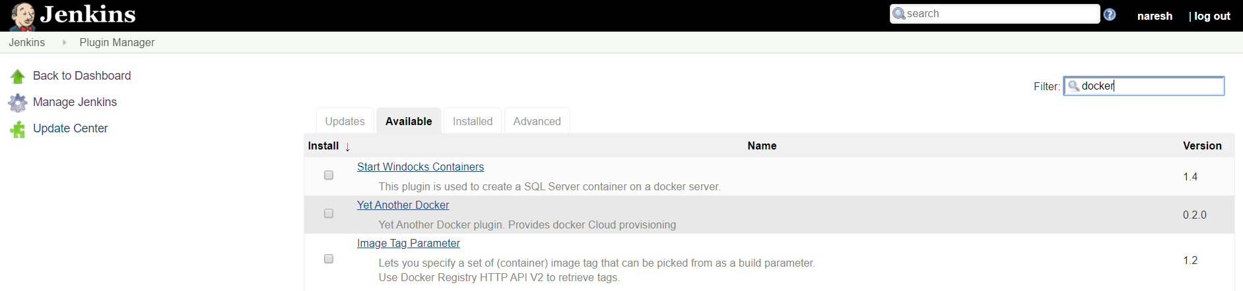

Click Available and search docker plugins

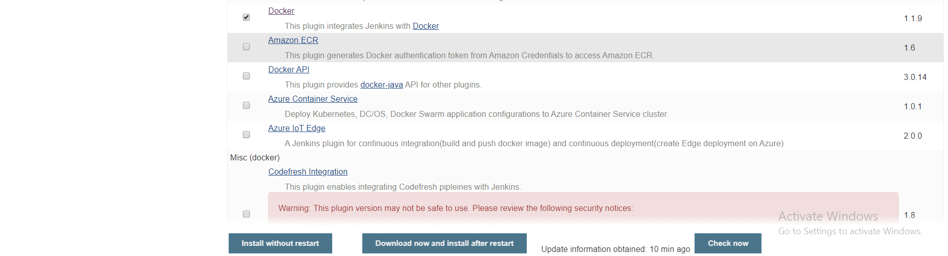

Click on **Install without restart**

Create credentials to connect Jenkins Slave container

Goto credentials

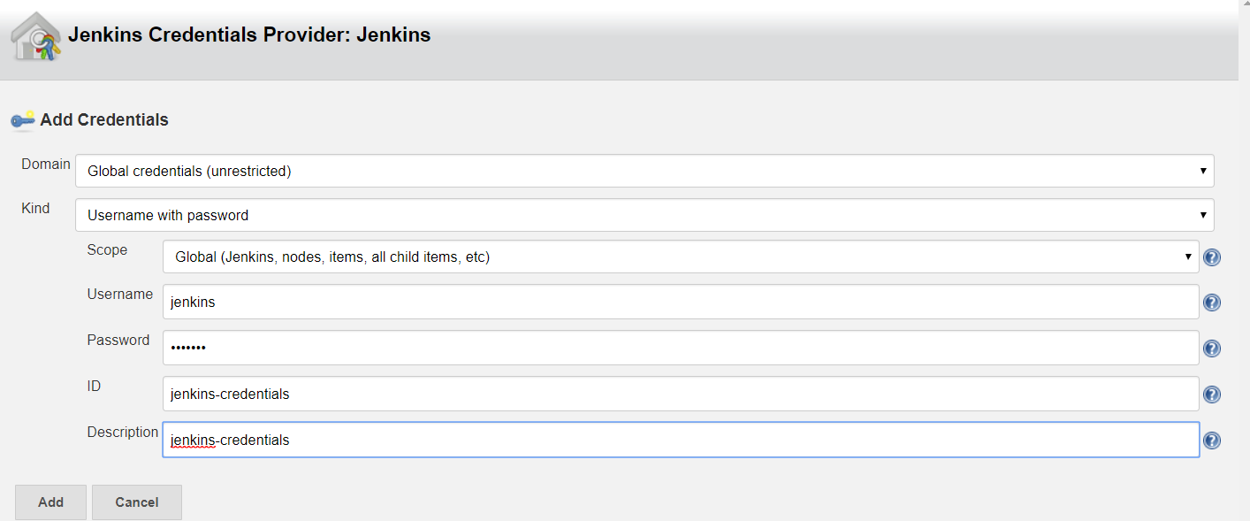

Back to Dashboard and Integrate Jenkins Slave with Master

Goto Manage Jenkins 🡪 Configure System

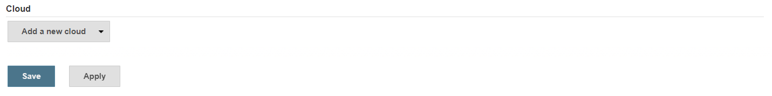

Click on **Add a new cloud**

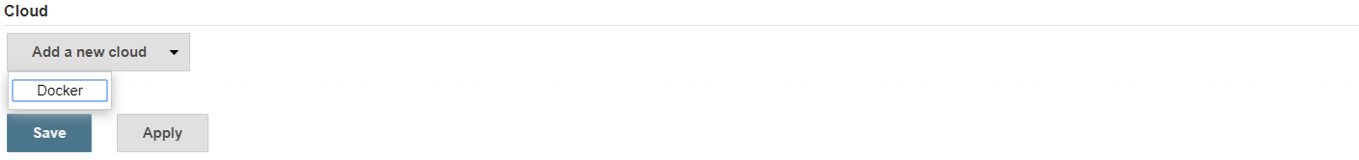

Click on **Docker**

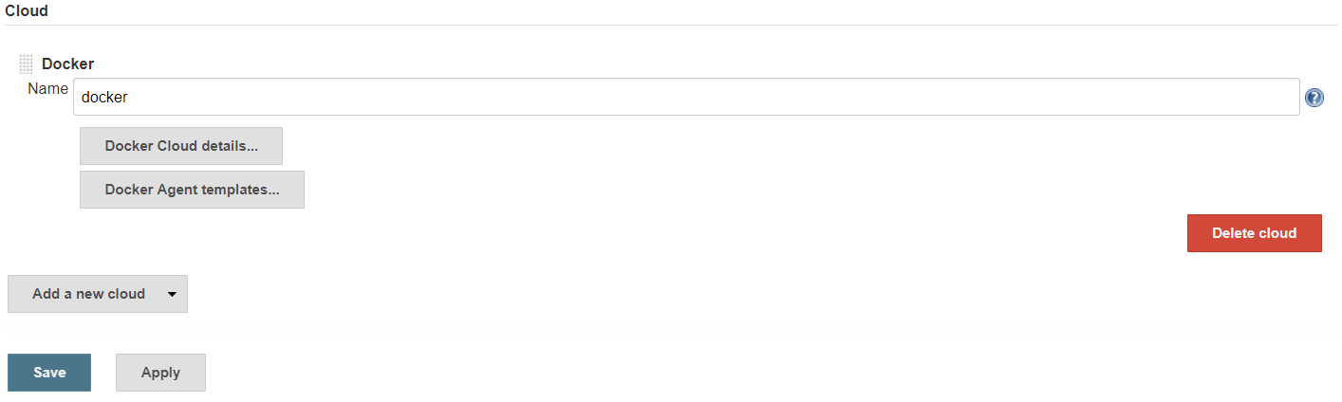

Click on **Docker cloud details**

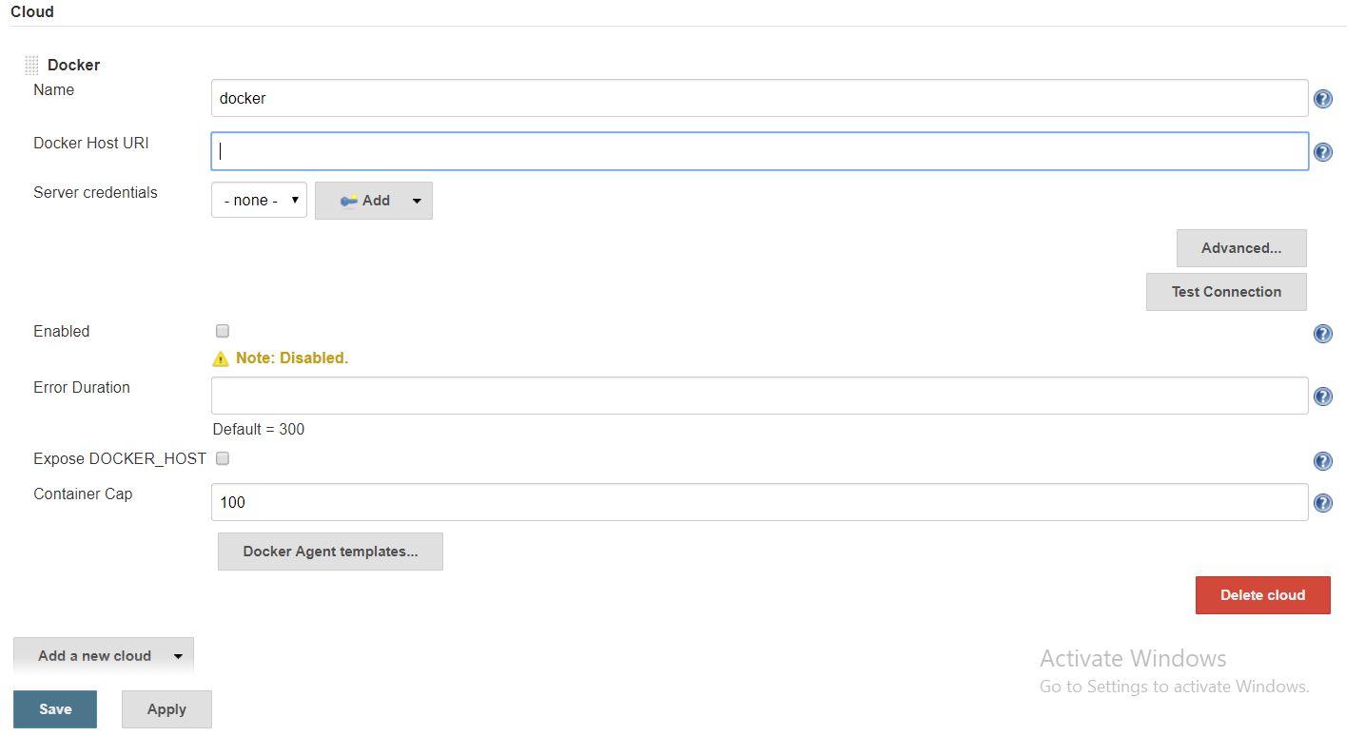

Give details as below

Docker Host URL : unix:///var/run/docker.sock

Click on Test Connection

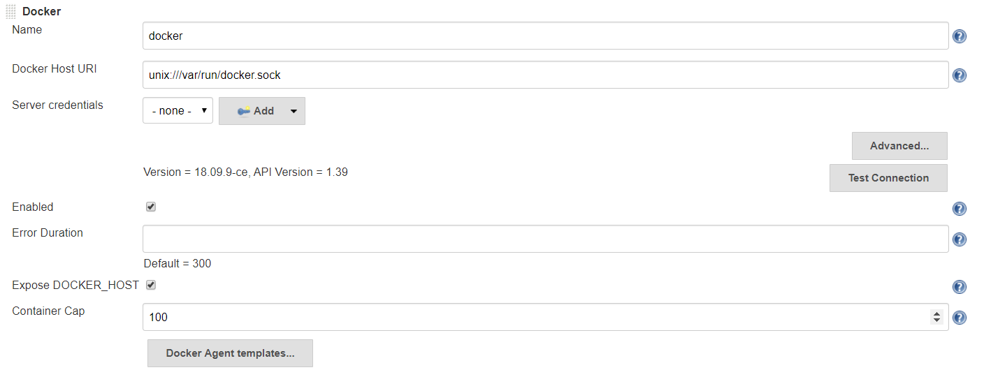

Click on Docker Agent templates

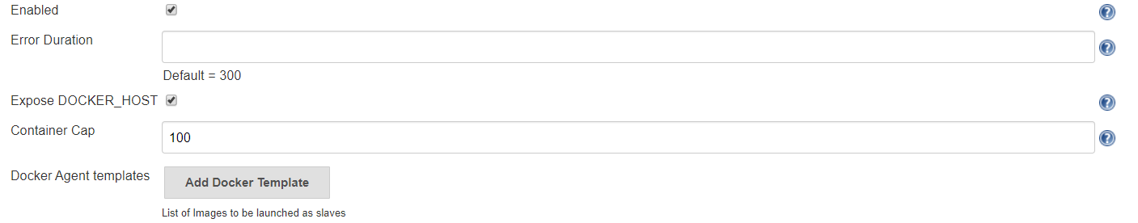

Click on Add Docker Template

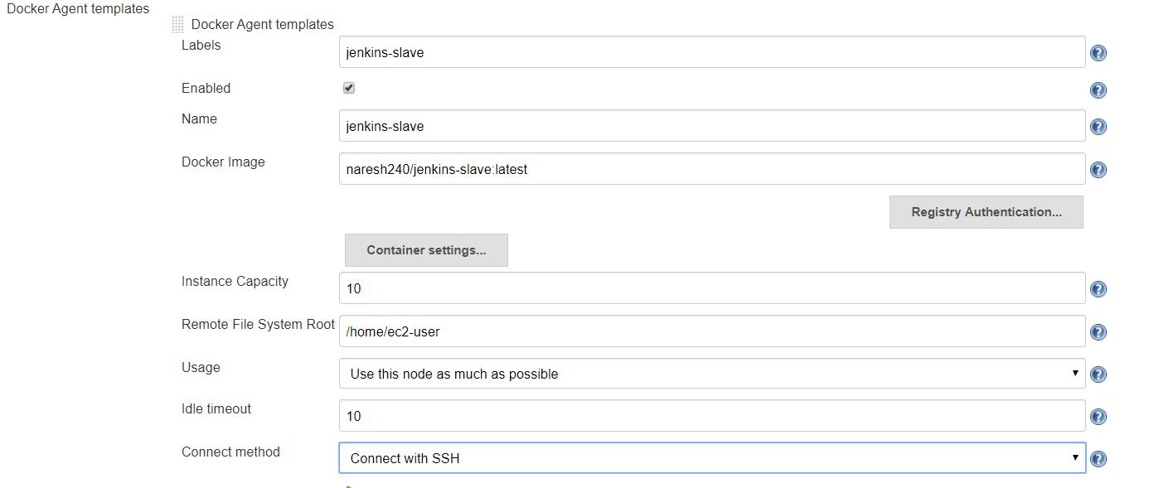

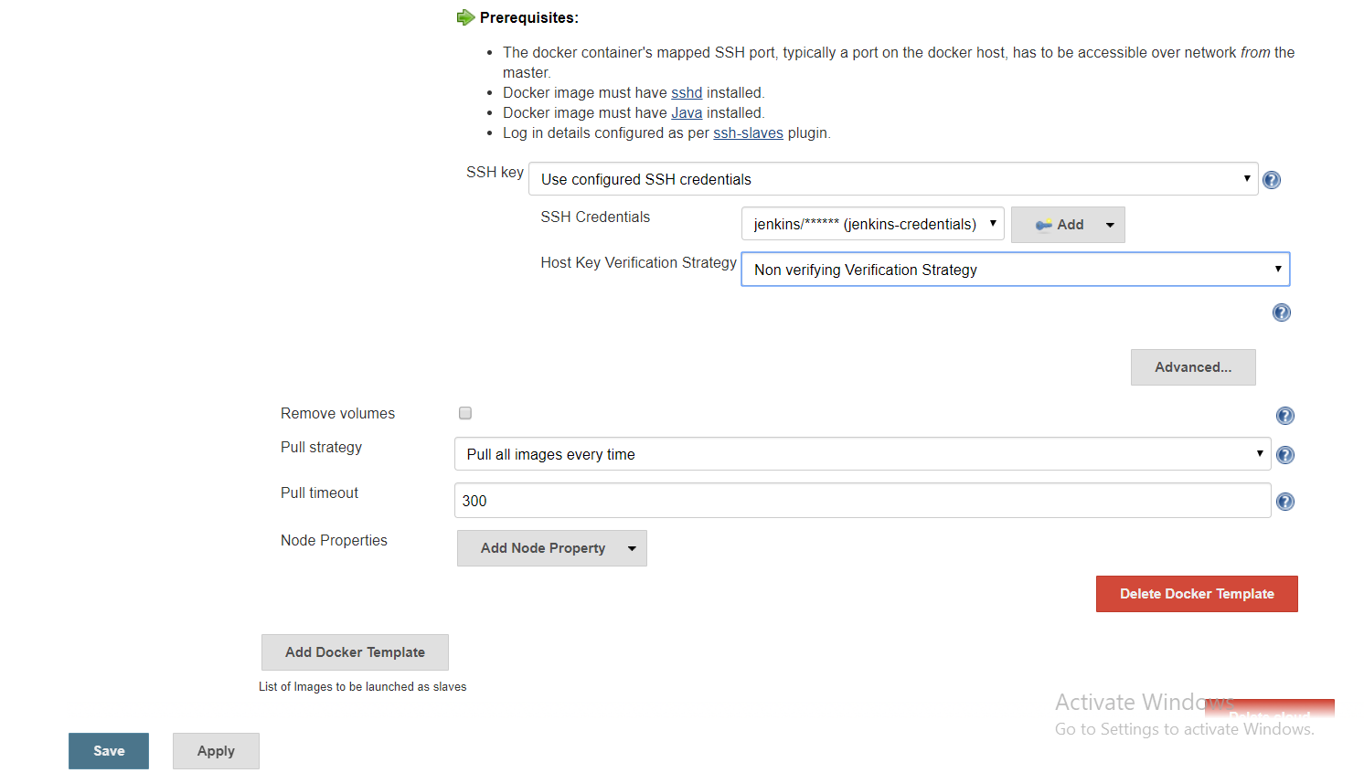

Give details as above and click on **Save**

Create a New job:

Click on New Item

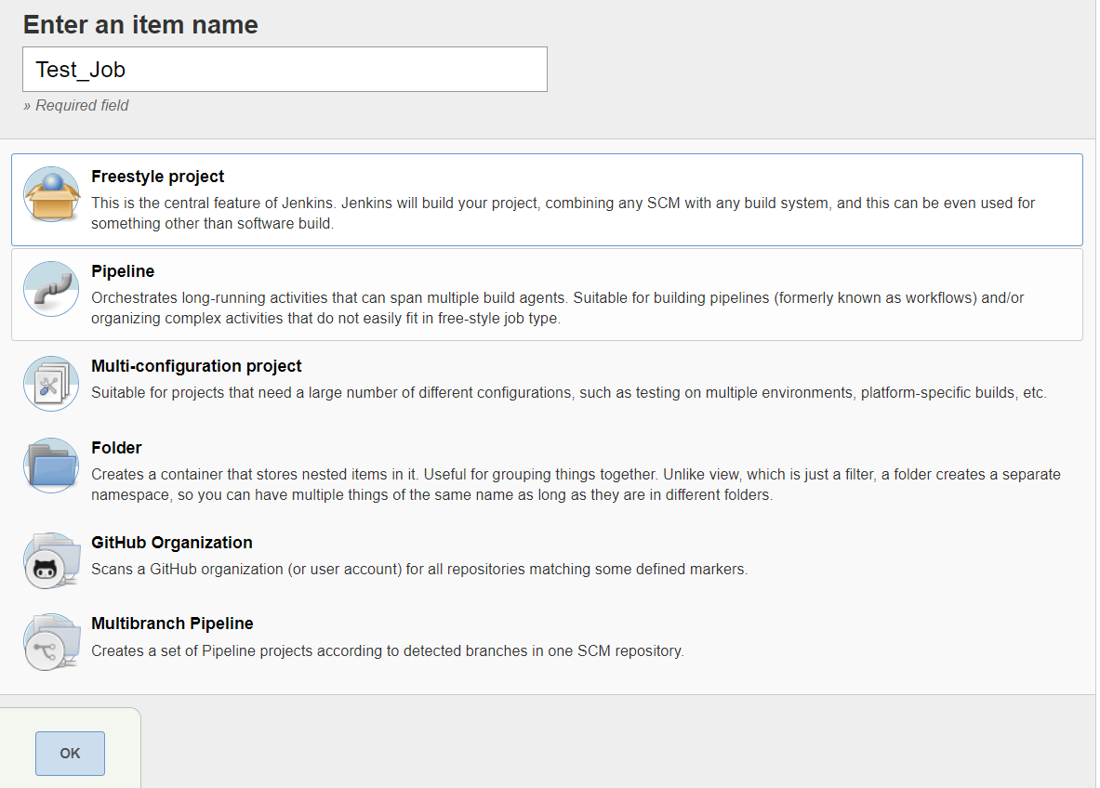

Enter an Item Name

Select Freestyle Project and Click on **Ok**

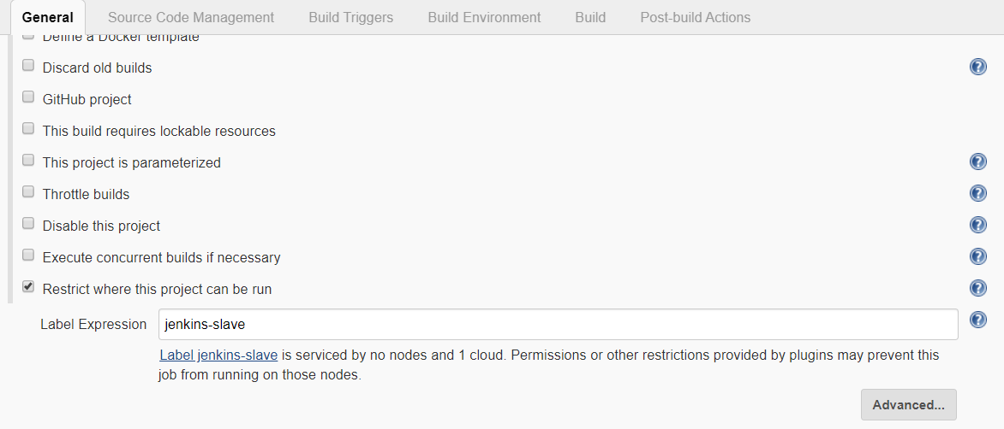

Give lable name which was we given while integrating slave with Jenkins master

Goto Build Section and select **Execute shell**

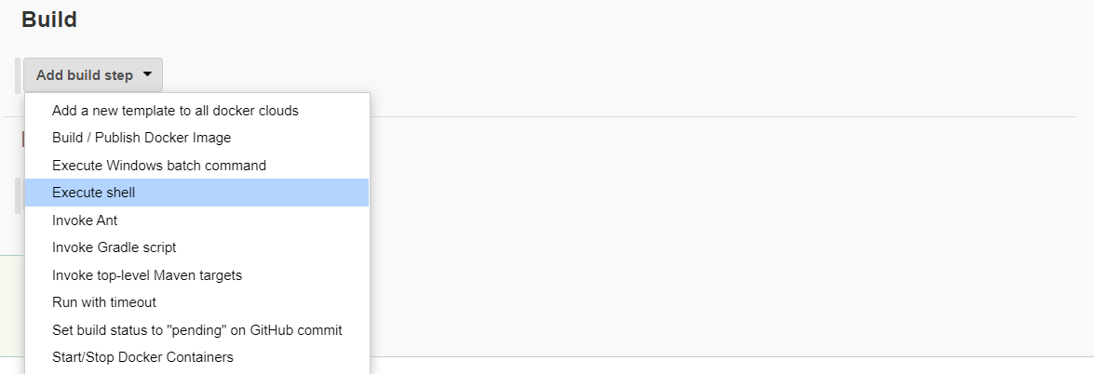

Give echo command with in the Execute shell

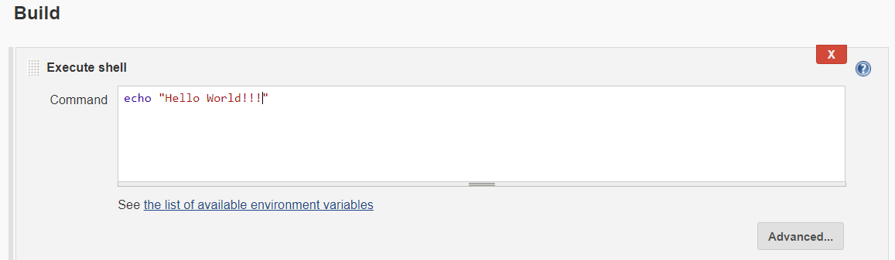

Click on **Save**

Click on **Build**

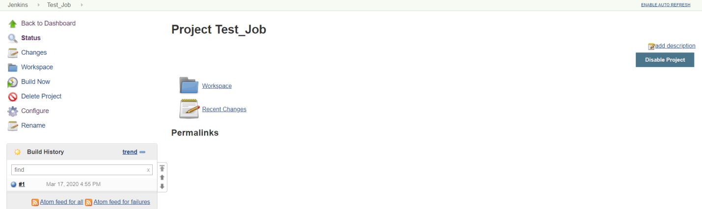

Open Console output

